**PRICE:** $28.49

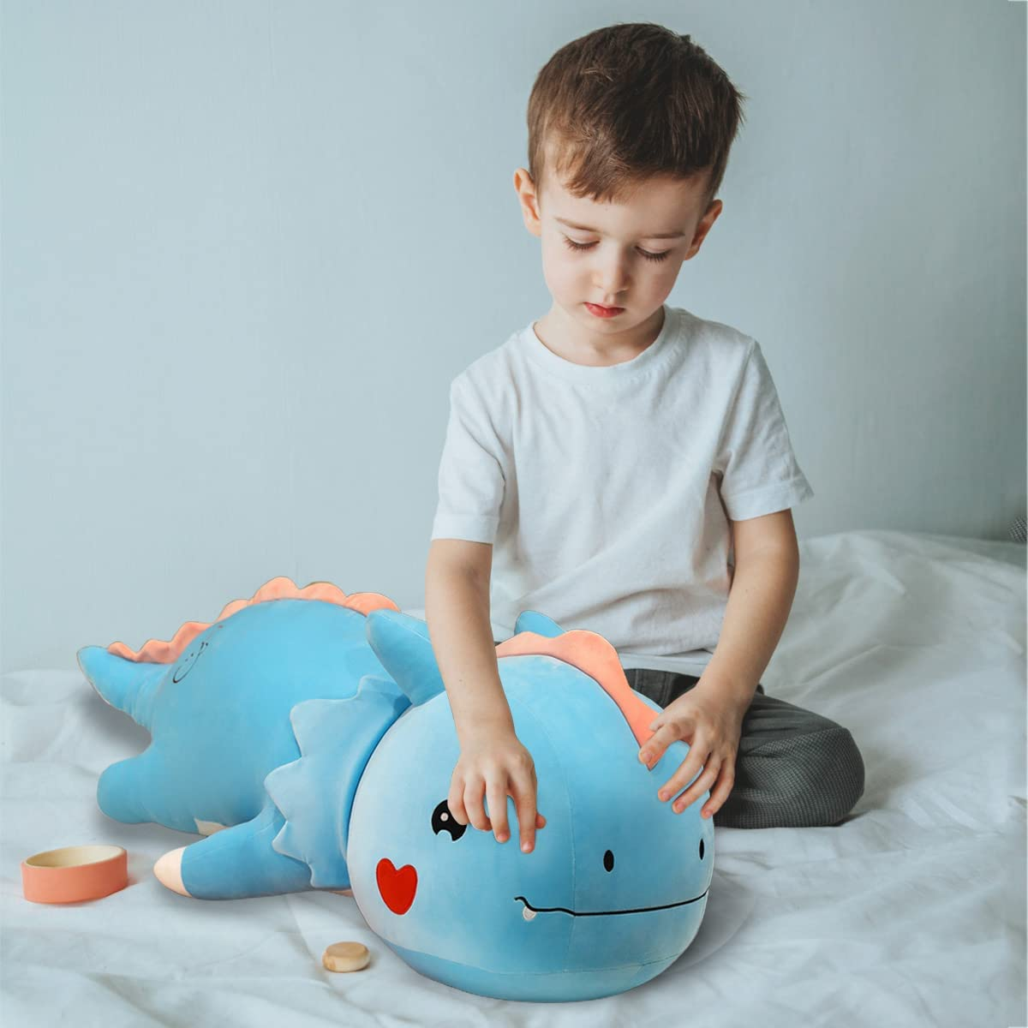

**Size:** 31.4in/80cm

**Color:** Blue

* SAFE MATERIAL: Super soft and fluffy plush stuffed animal , the plush dinosaur made of plush PP cotton, the natural eco-friendly plush cotton, and filling, safe, soft, and friendly for children's skin. Popular dinosaur pillow, cute stuffed animals for your pillow collection.
* SOFT AND COMFY: Super soft dinosaur plush doll, filled with soft down cotton, holding soft, delicate touch, healthy and environmentally friendly, really comfortable, high quality plush toys. Super soft stuffed cuddle construction for extra snuggly comfort.
* PERFECT GIFTS: The perfect plush dinosaur gifts for children's birthday, Christmas, Valentine's Day, Halloween, etc. These cute small dinosaur stuffed animal toys can inspire children to explore the world of dinosaurs and are a good playmate. Popular dinosaur plush toy, will definitely be a pleasant surprise for kids and family, gift choice for birthday and Christmas.
* MULTIFUNCTIONAL USE: The stuffed dinosaur toy is a good plush pillow, sleeping, resting, and very soft when reading a book; you can also put it on the sofa, car, bedroom, children's room, etc. as an ornament. Appealing look makes it a lovely decor for living room, bedroom, office and car.
* SATISFACTION GUARANTEE: Our products run through multiple inspections and are designed with quality in mind. If you don't love it, we'll replace it or refund it! Maintenance Instructions:We recommend only hand washing, tumble drying. Dry cleaning or ironing will damage your plush toys.